Digital Eagle QR-09
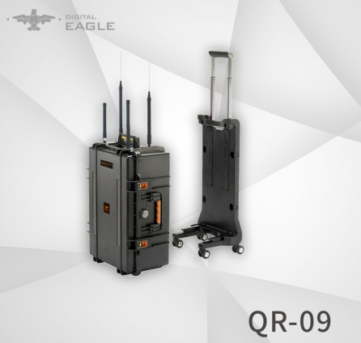
Technical Documents

Digital Eagle QR-09 Fixed jamming system
Applications:
Prevent remote controlled improvised explosive devices from being activated and stop terrorist attacks;
Protect explosives handling experts;
Protect important places such as bus/train stations, plazas, schools, mass gatherings, stadiums, etc;
Risk mitigation and explosives removal in specified spots;
Police used for VVIP convoy, ECM, anti drug, riot control, etc.
Military used for border control, ECM etc.
Features:
- Non-invasive Fixed jamming system
- It can be operated by one (1) person in less than three minutes

Technical Parameters
Brand | Digital eagle | Model | QR-09
Reference | Fixed jamming system | Operation | Operated by 1 person
Dimensions | 820*540*360mm | Weight | 20kg
Operation Frequency | 2.4GHz, 5.8GHz, GPS, GLONASS, GALILEO L1 | Antenna | Directional Antenna &Omni antenna
Effective range | Omni:500m  Directional:1500m | Type of operation | Blocker operating frequencies
Jamming type | Lock and block operation and transmission and navigation of UAV.  - RTH  - Landing immediately | Control of output power | Adjustable 2 levels
Working time | 24hrs*7 | Power source | AC input
AC input voltage | Customized for all countries | Warranty | 1 year
Operation temperature | -25℃ ~ +60℃ | Wheel case | Yes
Control Panel | Integrated with main body

