Digital Eagle QR-07S3
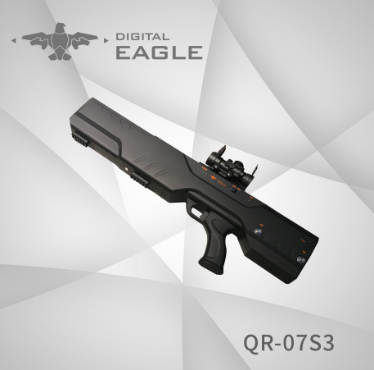
Technical Documents

Digital Eagle QR-07S3 Hand Gun portable jamming system
Applications:
Prevent remote controlled improvised explosive devices from being activated and stop terrorist attacks;
Protect explosives handling experts;
Protect important places such as bus/train stations, plazas, schools, mass gatherings, stadiums, etc;
Risk mitigation and explosives removal in specified spots;
Police used for VVIP convoy, ECM, anti drug, riot control, etc.
Military used for border control, ECM etc.
Features:
- Handgun with adjustable armrest
- It can be operated by one (1) person in less than three minutes
- Lightweight system with a total weight of less than 20 kg.
- Effective range of 1500 m.

Technical Parameters
Brand | Digital Eagle | Model | QR-07S3
Reference | Hand Gun portable jamming system | Control unit | Internal, integrated with body
Package | Kitbox  internal part has high density polyurethane foam  external case with wheels | Weight with box | 9kg
Dimensions | 746*228*79mm | Weight with battery | 4kg
Operation Frequency | 832-932MHz,2.4GHz, 5.8GHz, GPS, GLONASS, GALILEO L1 | Antenna | Directional Antenna
Effective range | 1500m | Type of operation | Blocker operating frequencies, manual action.
Jamming type | Lock and block operation and transmission and navigation of UAV.  - RTH  - Landing immediately | Control of output power | Adjustable 2 levels
Working time | 60mins | Battery | 2pcs of rechargeable lithium batteries
Standby times | 24hrs | Battery charger | Customized for all countries
Operation temperature | -25℃~+60℃ | Warranty | 1 year

Packing List
- Drone Jammer Gun*1
- Telescope*1
- High capacity Lithium battery*2
- Battery charger*1
- Restraint harness the rifle *1
- Tripod*1
- Anti-shake ,Anti-dust, waterproof carrying case*1

